## PURPOSE:

The purpose of this SOP is to describe the responsibilities, processes and documentation of temperature and humidity monitoring of storage areas, and storage fridges and freezers for Investigational Medicinal Products (IMP), other temperature sensitive products (e.g. ancillary supplies such as laboratory kits) and biospecimen samples.

## SCOPE:

The principles of this SOP may be applied to any temperature-controlled storage area for biological specimens and materials used for any research activity conducted at Epworth.

## APPLICABILITY:

This applies to all Epworth employees, non-employed staff and Visiting Medical Officers (VMOs) and to all relevant external persons who work within temperature monitored areas or store temperature sensitive materials in facilities while conducting research at Epworth.

## DEFINITIONS:

* 1. Building Management System (BMS) – Centralised systems located at Epworth Freemasons and Epworth Richmond respectively that monitor real-time temperature of each of the fridges and freezers via remote access.
  2. Epworth Freemason Grey Street satellite laboratory (“Grey Street”) – Located in the Clinical Trials Unit, Basement 1 (B1) of 124 Grey St, East Melbourne.
  3. Epworth Freemasons Facilities – Provides facilities management for the Epworth Freemasons building including B1, Clinical trials Unit and the satellite laboratory.
  4. Epworth Hoddle Street molecular processing laboratory (“Hoddle Street”) – Located at Level 1 of 185 Hoddle St, Richmond.
  5. Epworth Richmond Facilities – Provides facilities management for the 185-187 Hoddle Street building
  6. Laboratory Manager – staff member of the Epworth Centre of Immunotherapies and Snowdome Laboratories (ECI&SL), with delegated responsibility by the Office for Research (OfR) to provide oversight of Epworth Research biospecimen stored in freezers/fridges temperature monitoring, and environmental temperature and humidity monitoring for each of the laboratory environments for all the Epworth research teams that utilise the laboratory services.
  7. MOCI - Molecular Oncology and Cancer Immunology

## PROCEDURE:

### Temperature monitoring of storage within fridges and freezers

* + 1. The temperature of all fridges and freezers used to store clinical trial and research laboratory samples must be continually monitored via a Building Management System (BMS). The BMS temperature set point for each fridge and freezer is determined by the Laboratory Manager.
    2. The freezers and fridge located at Grey Street laboratory are monitored via the Epworth Freemasons BMS.
    3. The freezers and fridges located at molecular processing laboratory at Hoddle Street are monitored via the Epworth Richmond BMS.
    4. Only research personnel that have access to the BMS can download, print, and review temperature data each month.
    5. Monthly readouts of temperatures of each fridge and freezer will be stored in a SiteDocs folder that can be accessed by users of freezers and fridges, and should be made available whenever requested by Laboratory Manager, Office for Research (OfR), sponsors, or auditors.
    6. Any set point temperature excursions duration, cause, and resolution must be documented, checked and signed off by the Laboratory Manager. The temperature set points are outlined in Appendix 3.
    7. It is the responsibility of the freezer/fridge users to ensure freezer and fridge doors are closed after use, and temperatures are within range after access.
    8. It is the responsibility of the freezer/fridge users to label and document any items and biospecimen samples stored in the freezer and fridge that belong to their Research Group.
    9. All items and biospecimen samples must be traceable to the study team who owns them.
    10. Clinical trial and research teams are required to have internal process in place to ensure that appropriate disposal of biospecimens from both fridges and freezers are made in the event that a sample is no longer viable, and if items are expired.

### 5.2 Alarm monitoring of fridges and freezers - Epworth Freemasons Grey Street satellite laboratory (Basement 1)

#### Temperature alarms triggered **during work hours (8.30am – 5pm)**

* + - 1. Staff who noted the fridge/freezer alarm will inform the haematology clinical trials and/or MOCI team located at Grey St.
      2. The haematology clinical trials and/or MOCI team will determine the cause of the alarm and implement corrective actions as required.
      3. If required, the haematology clinical trials and/or MOCI teams will contact the service provider to arrange service or repair of equipment, and notify Epworth Freemasons Facilities, (Appendix 4), Laboratory Manager, and Research Program Manager of the outcome.
      4. If uncertain of the duration of temperature excursion, the haematology clinical trials and/or MOCI teams will contact Epworth Freemasons Facilities to review the BMS temperature record.
      5. If the temperature excursion exceeds two hours, the haematology clinical trial and/or MOCI team must inform other freezer/fridge users, and users must ensure storage items and biospecimens are managed according to steps outlined in *5.2.1.5.1* to *5.2.1.5.3* respectively.

##### 5.2.1.5.1 Alarms triggered by -80˚C freezer

1. If required, the haematology clinical trial and/or MOCI teams will relocate all items from the upper ‘critical’ shelf of the -80˚C freezer to the -20˚C freezer located in the utilities room.

##### 5.2.1.5.2 Alarms triggered by -20˚C Freezer

1. The haematology clinical trial and/or MOCI teams will notify the Research Program Manager and/or Clinical Trial Manager and/or Laboratory Manager of the excursion who will decide whether to transfer reagents/biospecimen to another designated -80˚C or -20˚C freezer.

##### 5.2.1.5.3 Alarms triggered by 4˚C Fridge

1. The haematology clinical trial and/or MOCI teams will notify the Research Program Manager and/or Clinical Trial Manager and/or Laboratory Manager of the excursion who will decide whether to transfer reagents/biospecimen to another designated 4˚C fridge.

#### Temperature alarms triggered **outside of work hours** **(5pm – 8.30am)**

* + - 1. Epworth Freemasons Security (9483 3555) will receive the BMS temperature alarm and attend site to determine the cause of the alarm and corrective actions required.
      2. Epworth Freemasons Security (9483 3555) or Freemasons Facilities will escalate if temperature excursion exceeds two hours to the Epworth Freemasons Hospital Coordinator via 0437 039 225.
      3. If temperature excursion exceeds two hours outside of work hours, storage items and biospecimen in the freezers/fridges are managed according to steps *5.2.2.3.1* till *5.2.2.3.3*.

##### 5.2.2.3.1 Alarms triggered by -80˚C freezers

1. Epworth Freemasons Security/Facilities will advise the Hospital Coordinator (0437 039 225) who will relocate all items on the upper ‘critical’ shelf of the -80˚C freezer to the -20˚C freezer located in the utilities room (See map on Appendix 1).
2. Hospital Coordinator to notify the Research Program Manager or Clinical Trial Manager or Laboratory Manager of the freezer users of the excursion on next available business day
3. If required, the Hospital Coordinator will coordinate with Epworth Facilities regarding contacting the service provider to arrange service/repair.

##### 5.2.2.3.2 Alarms triggered by -20˚C freezers

1. Hospital Coordinator to notify Research Program Manager or Clinical Trial Manager or Laboratory Manager of the freezer users the next business day.

##### 5.2.2.3.3 Alarms by 4˚C fridges

1. Epworth Security/Facilities advise the Research Program Manager or Clinical Trial Manager or Laboratory Manager of excursion on next available business day.

### 5.3 Alarm monitoring of fridge and freezers – Molecular Processing Laboratory, 185 – 187 Hoddle Street (Level 1)

#### Temperature alarms triggered **during work hours (8.30am – 5pm)**

* + - 1. Staff who noted the temperature alarm will inform the ECI&SL team (9426 0555).
      2. ECI&SL team to determine the cause of the alarm and implement corrective actions as required.
      3. If required, the ECI&SL team will contact the service provider to arrange service or repair of equipment and notify Epworth Richmond Facilities (Appendix 4), Laboratory Manager and Research Program Manager of freezer/fridge users of outcome.
      4. If temperature excursion exceeds two hours, ECI&SL team must inform other freezer/fridge users, and users must ensure storage items and biospecimens are managed according to steps outlined in *5.3.1.4.1* to *5.3.1.4.3* respectively.

##### 5.3.1.4.1 Alarms triggered by -80˚C freezer

1. ECI&SL team will notify the Research Program Manager or Clinical Trial Manager or Laboratory Manager of the freezer users of the excursion who will decide whether to transfer biospecimens to another -80˚C freezer.

##### 5.3.1.4.2 Alarms triggered by -20˚C Freezer

1. ECI&SL team will notify the Research Program Manager or Trial Manager or Laboratory Manager of the freezer users of the excursion who will decide whether to transfer reagents/biospecimens to another designated -80˚C or -20˚C freezer.

##### 5.3.1.4.3 Alarms triggered by 4˚C Fridge

1. ECI&SL team will notify the Research Program Manager or Trial Manager or Laboratory Manager of the fridge users of the excursion who will decide whether to transfer reagents/biospecimens to another designated 4˚C fridge.

#### Temperature alarms triggered **outside of work hours (5pm – 8.30am)**

* + - 1. Rostered on-call personnel will be notified via SMS alert of a temperature, humidity or generator alarm and will review the Richmond BMS for further clarification. If the biospecimens are deemed to be at risk (i.e. excursion exceeds 2 hours), the on-call personnel will attend site within 90 minutes and implement corrective actions according to *5.3.2.1.1* to *5.3.2.1.3*.

##### 5.3.2.1.1 Alarms triggered by -80˚C freezers

1. Rostered on-call personnel will escalate to the Laboratory Manager if required, and/or notify the freezer users of the excursion on next available business day.
2. If required, the rostered on-call personnel will coordinate with Epworth Richmond Facilities regarding contacting the service provider to arrange service/repair.

##### 5.3.2.1.2 Alarms by -20˚C freezers

1. Rostered on call personnel to notify the Laboratory Manager of the freezer users the next business day.

##### 5.3.2.1.3 Alarms by 4˚C Fridges

1. Rostered on call personnel to advise the Laboratory Manager of the fridge users of excursion on next available business day.

### Monitoring of other temperature-controlled storage areas

* + 1. If Epworth clinical research staff are responsible for the storage of the Investigational Product (IP), the IP must be stored in a locked, restricted access location which is temperature monitored. Generally, IP is managed and stored at the Slade Pharmacy who maintain temperature monitoring and records for the IP.
    2. Molecular Processing Lab, 185 – 187 Hoddle Street is temperature controlled and humidity monitored via Epworth Richmond BMS.

## REFERENCES:

N/A

## RELATED DOCUMENTS:

N/A

## VERSION CONTROL

|  |  |  |  |
| --- | --- | --- | --- |
| Document History | | | |
| Version | Date | Summary of Changes | Author |
| 1.0 | 24 June 2019 | N/A First Issue | Helen Christensen |
| 2.0 |  | Major update to include details on alarm monitoring, and management of storage items and biospecimens at Freezers and Fridges stored at Grey St and Hoddle St during temperature excursions.  Dot points have now been converted to numbers. | Nicole Brooks |

## APPENDIX

Appendix 1: Location of fridge and freezers - Grey Street satellite laboratory, Epworth Freemasons

**Clinical Trials Unit - Basement 1 , 124 Grey St**

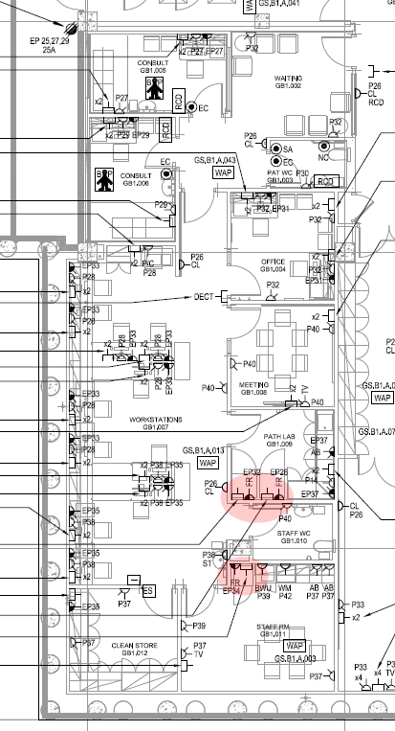

 -20˚C Freezer

 4˚C Fridge

 -80˚C Freezer

Appendix 2 - Location of fridge and freezers – Hoddle Street molecular processing laboratory, Richmond.

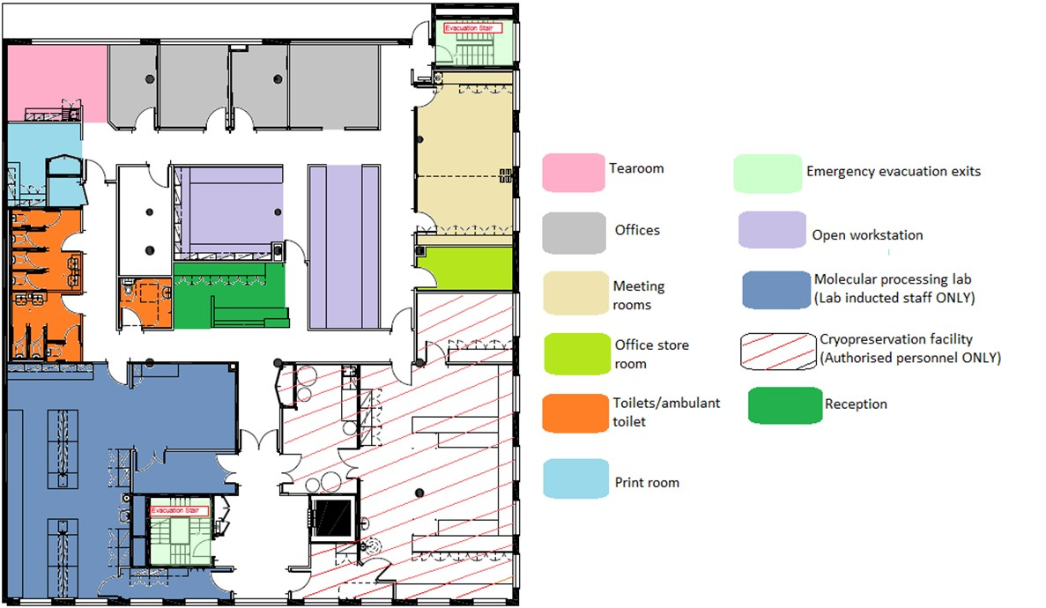

**Fridge and Freezers**



Appendix 3 – (a) Temperature range and location of equipment – Grey Street satellite laboratory.

|  |  |  |  |  |  |
| --- | --- | --- | --- | --- | --- |
| **Equipment** | **Name on BMS** | **Serial number** | **Location/Room Name** | **Alarm Set Limits** | |
| **High** | **Low** |
| LabGear  -20˚C Freezer | B1-01 Clean Store Freezer | 152002170184 | Level B1, Grey St  Clean Store GB1.012 (EP35) | -10˚C | -30˚C |
| Panasonic  -80˚C freezer | B1-02 Pathology Lab Freezer | 16010041 | Level B1, Grey St  Path Lab GB1.008 (EP26) | -65˚C | -90˚C |
| Paragon Care 4˚C fridge | B1-03 Pathology Lab Fridge | 1642 | Level B1, Grey St  Path Lab GB1.008 (EP32) | 8.0˚C | 2.0˚C |

(b) Molecular Processing Laboratory, 185 – 187 Hoddle Street (Level 1)

|  |  |  |  |  |  |
| --- | --- | --- | --- | --- | --- |
| **Equipment** | **Name on BMS** | **Serial number** | **Location/Room Name** | **Alarm Set Limits** | |
| **High** | **Low** |
| Snijders  -80˚C freezer | Freezer 02 | VF721801937 | Molecular Processing Laboratory, Level 1, Hoddle St | -65˚C | -90˚C |
| PHCbi ECO VIP  -80˚C freezer | Freezer 01 | 19120458 | Molecular Processing Laboratory, Level 1, Hoddle St | -65˚C | -90˚C |
| Nuline -20˚C freezer | Freezer 04 | 16751 | Molecular Processing Laboratory, Level 1, Hoddle St | -10˚C | -30˚C |
| Paragon Care 4˚C Pharmacy fridge | Fridge 03 | 1620 | Molecular Processing Laboratory, Level 1, Hoddle St | 8.0˚C | 2.0˚C |

Appendix 4 - Steps to notify Facilities

1. Go to intranet.epworth.org.au
2. Click ‘Corporate’ on the top tab, and choose ‘Facilities and Asset Management’.
3. Click ’ Work Request’ on the left tab and create a Work Request.
4. Please use Username and Password of ‘Freemasons’ and ‘Richmond’ for freezers/fridges located at 124 Grey St, and 185 Hoddle St respectively.

